**CP Club 365 Days Challenge**

**Programming language – Any language**

**Problem Statement**

<https://www.codechef.com/problems/EVMHACK>

**Your Code**:

// 0x95Day of 0x365Days challenge

// VEDANT BHARAD

// 20-1-2023

#include <iostream>

using namespace std;

int main()

{

    int t;

    cin>>t;

    while(t--)

    {

        int a,b,c,p,q,r;

        cin>>a>>b>>c>>p>>q>>r;

        double sum =a+b+c+(max(p-a,(max(q-b, r-c))));

        if(sum>((p+q+r)/2))

            cout<<"YES"<<endl;

        else

            cout<<"NO"<<endl;

    }

    return 0;

}

**Output (Screen Shot)**:

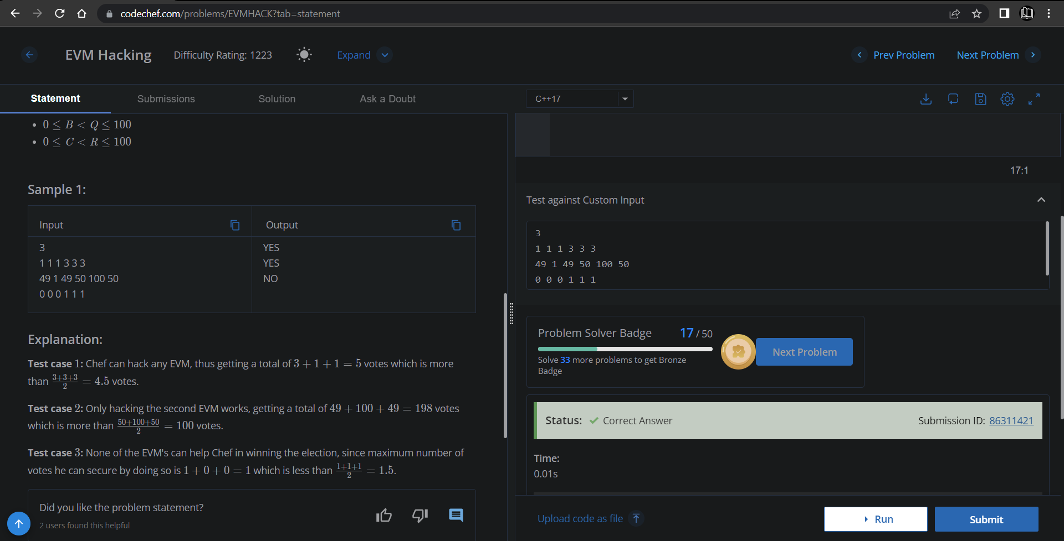

**Understanding about problem:**

Note: If you can't understand the problem, feel free to contact us and we'll help you. Please don't copy and paste from anywhere.

ALL THE BEST

Team CP Club